09th October 2026

Dear Colleague

Annual General Meeting
The Loft Lounge and Bar | 14 Station Street
Wednesday 11th November 2026 at 6pm

Notice is hereby given that the Annual General Meeting of Your Eastbourne BID Limited will be held on Wednesday 11th November 2026 at 6.00pm, when it is hoped you will be able to attend.

The papers for the meeting, including the minutes of the AGM 11th November 2025 and the accounts for 2024/25 are available via the BID’s website on the Home Page at http://www.youreastbournebid.com.

Please follow the link on our website to register your place so that you can be afforded voting rights at the AGM. We ask that you RSVP to attend by Monday 9th November 2026 by using the links on our website.

Details of proxy voting are also available on the BID website. There are no passwords required to access this part of the site.

AGENDA
- To read the notice convening the Meeting.
- Apologies for absence.
- Approval of the Minutes of the AGM on 11th November 2025
- To receive, consider and adopt the Annual Accounts, Balance Sheet & Auditors’ Report for the year to 31st August 2025.
- To re-elect Directors to the Board of Your Eastbourne BID
- To receive new nominations for Directors, to be considered by the Board at the first Board meeting post AGM
- To receive, consider and approve the Chair’s Report for 2024 - 2025 including updates on 2026 and 2027 activities
- Any other business which the Chair may admit

Drinks and canapés will be served and there will be opportunities for networking and discussion with the BID’s Board of Directors and staff, along with our members.

Please bring your personal copy of the relevant AGM papers with you.

The Board of Directors, BID Team and I look forward to seeing you on Tuesday 11th November 2026.

Yours sincerely
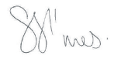 | 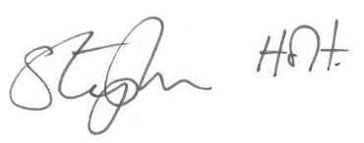
Shoes Simes Stephen Holt
Chair Chief Executive

